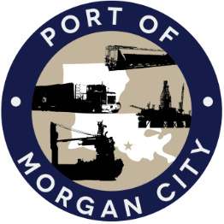

AGENDA

MORGAN CITY HARBOR AND TERMINAL DISTRICT
Regular Meeting of April 12, 2021 – 5:00 p.m. – 7327 Highway 182

- Call to Order

- Roll Call, Invocation and Pledge of Allegiance

3. Minutes – approval of Regular Meeting of March 8, 2021

4. Finance Report
A. Presentation and discussion of financial reports for March 2021 – Deborah Garber
B. Invoices

5. Guest(s)/Public Comment
A. Corps of Engineers, New Orleans District
B. United States Coast Guard

6. Raymond “Mac” Wade - Executive Director’s Report
A. Consultant – Michael Knobloch, Knobloch Professional Services, LLC
B. Consultant – Charles Brittingham, Cassidy & Associates
C. Consultant – Terral Martin, Providence Engineering
D. Consultant - O’Neil Malborough, GIS Engineering
E. Cindy Cutrera, Manager of Economic Development

7. Gerard Bourgeois - Legal Report

8. New Business
A. Discussion and any action on resolution providing for the execution of certain banking agreements
B. Discussion and any action on Port Priority grant requests, agreement for services of T. Baker Smith and purchase of property adjacent to the District’s Dock

9. Old Business
A. Discussion and any action on leasing, improvements, maintenance and repairs to facility(ies), including Coast Guard lease(s)
B. Discussion and any action regarding the U.S. Department of Homeland Security grant program, including request for proposals, bids, purchases, maintenance for equipment, software and NOAA ports system(s)
C. Discussion and any action on Atchafalaya River Channel including dredging and sediment management, equipment purchases, reports, survey services, consulting services, economic study(ies), landowner agreements; right of entry for U.S. Army Corps of Engineers and cooperative agreement(s)

10. Adjournment

In accordance with the Americans with Disabilities Act, if you need special assistance, please contact Tori Henry at 985-384-0850, describing the assistance that is necessary.

